«АҒЫЛШЫН ТІЛІ САБАҒЫ: ПОЗИТИВТІ ЭМОЦИОНАЛДЫ ӨЗАРА ӘРЕКЕТТЕСУДІ ҚҰРУ ТӘЖІРИБЕЛЕРІ» курсы бойынша «Snack attack» тақырыбы бойынша сабақ жоспары

Unit 6: Healthy World |  | Lesson 43
Teacher name: |  | Kabylkhanov Nursat Talgatuly

Date:
Grade: 4 |  | Number present: | absent:
Lesson title | Snack Attack
Learning objectives | 4.1.10.1 recognise words similar to words in student native language  4.2.7.1 contribute a growing range of suitable words, phrases, and sentences including giving opinions during short pair, group and whole class exchanges
Lesson objectives | Learners will be able to:  - recognize cognates (words in English similar to their native language) to enhance their vocabulary recognition and comprehension.  - practise talking about plans and intentions.  - learn how to distinguish between and pronounce the consonant clusters sk, sn and sp.
Plan

Stages / Time | Teachers actions | Students actions | Assessment criteria | Resources
Beginning of the lesson  Warming-up  3 min  Pre-learning  «Brainstorming» method  7 min. | Organization moment :  1.Greeting.  Ask about the weather.  The teacher sets the lesson objectives, letting students know what to anticipate from the lesson.  Warming up  Where are you from?  How old are you?  What color is it?  How many students are there in class?  What day of the week today?  Lead-in   | The aim: To develop pupils speaking skills and create friendly atmosphere  Efficiency: By wishing each other they feel better and feel the support of others  Students of the class are listed.  Students' attention is drawn to the lesson.  Determines the topic and purpose of the lesson  Students say different words from the picture | The teacher to assess learners for their ability.  “Good job!  Well done!”  Formative Assessment  Good job!  Assessment criteria  - Learners have met the learning objectives if they can: To talk about snack Attack | PPT  pictures  Student’s book
Middle of the lesson  Presentation part.  30 min | Ex:10 P:86  Play the CD. The pupils listen and follow the texts in their books. Ask the pupils to tell you if they know any Play the CD.  • Go through the pictures of the text and set the scene by asking the pupils questions about unusual snack, healthy snack and sweet snack.  Task Comprehension Check (True or False):  Task2: Read the text and decide if the statements are true (T) or false (F). If false, correct the sentence.  - Shubat is a type of cheese from Kazakhstan.  - The chocolate from Austria has a spicy flavor  - Jelly beans from the USA have a sweet and fruity taste.  - Fish and chips gelato combines two different foods.  - Octopus crisps come from Japan.  Task 2  Teacher gives the words to students and they must match them correctly.  A load of bread- бөлке нан  A jar of honey-банка бал  Crisps- чипсы  A pot of yogurt- йогурт  Peanut- жержаңғақ  Cracker-крекер  Watermelon- қарбыз  A carton of juice-қорап шырын  A bar of chocolate-шоколад  A bottle of cola-бөтелке кола  A packet of peas- пакет бұршақ  Walnut-жаңғақ  Task 3  Setup  In pairs or small groups, students will discuss their plans for the weekend, upcoming holidays, or a future event. They should use phrases like:  - "I am going to..."  - "I will..."  - "I plan to..."  Ex:13 P:87  Student listen carefully to the teacher’s pronunciation of each consonant cluster. | Pupils listen and read  ANSWERS  2 USA  3 Kazakhstan  4 Japan  5 Austria  6 China  Pupils choose the correct answer.  ANSWERS  1. F – It is camel’s milk.  2. F – It has peanuts and ketchup.  3. F – They taste like hot Tabasco sauce.  4.T  5. F – They come from South Korea.  Pupils have to match the words with translates.  Students will engage in conversation, using phrases like "I am going to," "I will," and "I plan to" to talk about their future plans and intentions.  Pupils listen, point and repeat  Answers  /sk/: skate, skip, sky  /sn/: snow, snake  /sp/: space, speak, sport | Descriptor:  - listens  - reads text  Total: 2 point  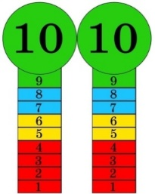  Self assessment  Descriptor:  - correctly identifies whether the statement is true or false.  - provides a correct correction or explanation when the statement is false.  Total: 2 point  Descriptor:  - correctly matches each word with its correct translation.  - connects the word in the first language  Total:2 point  Descriptor:  -uses "I am going to," "I will," or "I plan to" correctly to talk about future plans or intentions.  Total: 2 point  Descriptor:  -correctly pronounces the clusters sk, sn, and sp in words and sentences.  Total: 2 point | https://youtu.be/EQakwuBN0Ys?si=Wj-J0T5eVD1jLs86  https://wordwall.net/ru/resource/52824019  Worksheet  Students book
End of the lesson  5 min | FEEDBACK  Learners provide feedback on what they have learned at the lesson. | 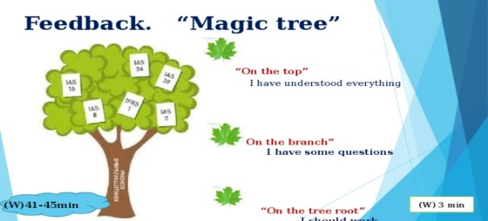 |  | Poster Success

